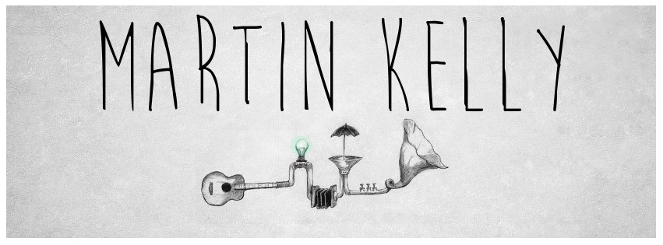

Martin Kelly is a Scottish singer/songwriter who has been making music since he was twelve years old. Growing in a small town just outside of Glasgow, Martin moved to the heart of the city at the age of eighteen and became fascinated with the vibrant music scene. Playing regularly in as many bands as would have him he started to hone his craft.

In 2008, a chance meeting with a German manager led to Martin moving to Berlin to pursue his musical path. Together with long term band mate and writing partner James O’Neill, they quickly caught the interest of Universal records Germany and released two albums as the duo Martin and James. The self titled debut album and it’s follow up ‘Life’s a show’ brought Martin and James a strong live fanbase and allowed the duo to tour Europe as well as support many successful artists such as Amy MacDonald, Taylor Swift, Paul Weller, Glen Hansard, Simply Red and many more.

Martin is currently living and working in Berlin as a musician and a songwriter. He is involved in several projects including a third Martin and James record and his first solo record.

www.facebook.com/martinkellymusic

www.facebook.com/martinandjames.official

