www.moveconcerts.com
info@moveconcerts.com
55 11 31997800

MOVE CONCERTS bids farewell to IRON MAIDEN as their Central and South American Tour ends
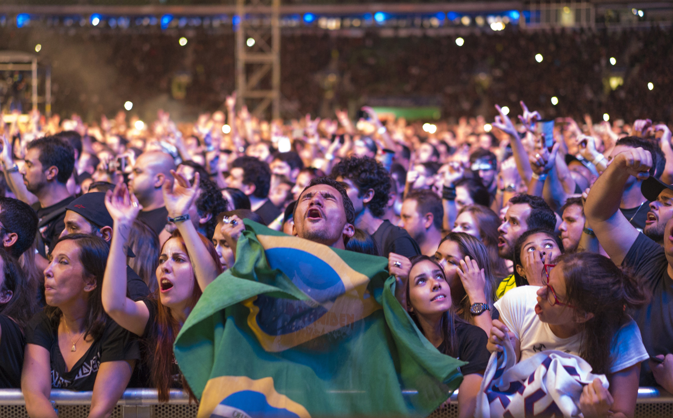
This past Saturday, 26th March, Iron Maiden ended their ten date tour of Central and South America with a sell-out concert at the 42,000 capacity Allianz Stadium in Sao Paulo. This tour marks the ninth tour of Central and South America that Iron Maiden has undertaken since their first concert appearance in the first edition of Rock in Rio in 1985.

By the time Saturday’s concert in Sao Paulo ended over a quarter million fans will have gone to the 10 concerts in the 5 countries (El Salvador, Costa Rica, Chile, Argentina and Brasil) the tour visited this time around proving that the power of Iron Maiden remains undimished in this region since their first Brazil appearance concert all of 30 years ago.
It isn’t an accident that Iron Maiden still remains a top tier concert draw in the region. In the past 31 years the band has returned to South America 8 times since their first appearance. Furthermore, Iron Maiden is the only major artist that has taken their show to 10 cities in Brazil over the years – Sao Paulo (8X), Rio de Janeiro (7X) , Curitiba (4X), Brasília (3X), Porto Alegre (2X), Belo Horizonte (2X), Recife (2X), Fortaleza, Campinas and Belém.
They have visited Argentina and Chile several times since 1992 having performed eight times in Buenos Aires, eight times also in Santiago and this year went to Cordoba for the first time to perform to 20,000 fans. No other major international artist has invested so much time and care for their local fans. This effort has resulted in constant sell outs and platinum record sales in Argentina, Brazil and Chile including their last chart topping release "The Book of Souls”.
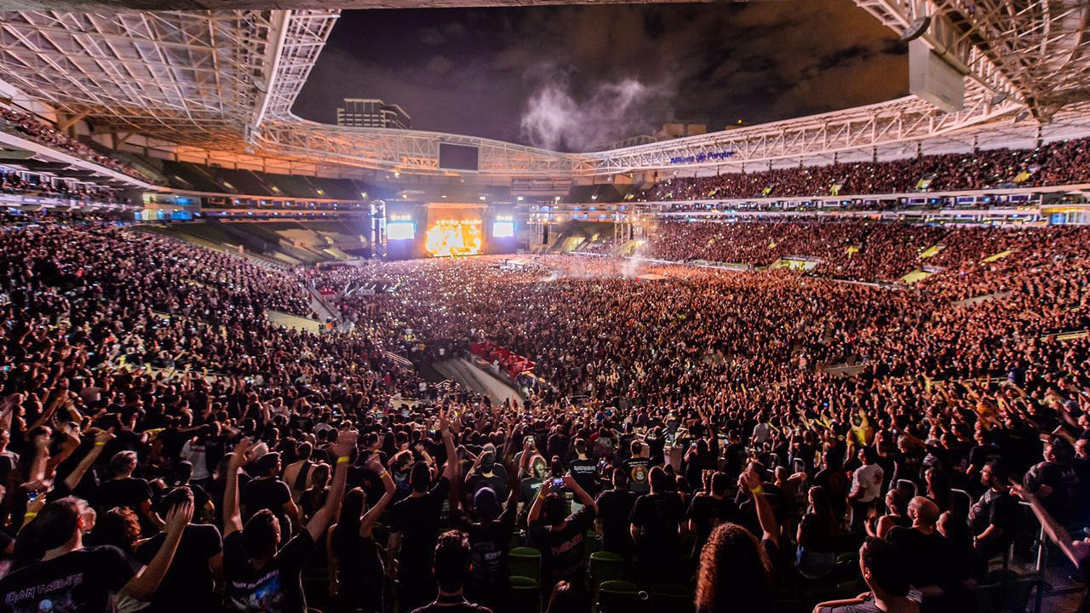
The band have also played in most South American countries including Argentina, Chile, Colombia, Ecuador, Peru, Paraguay, Uruguay and Venezuela. Brazil and all of South America loves Iron Maiden. And it's clear considering the bands history here Iron Maiden love Brazil and South America. We very much look forward too seeing them again soon.
www.ironmaiden.com

