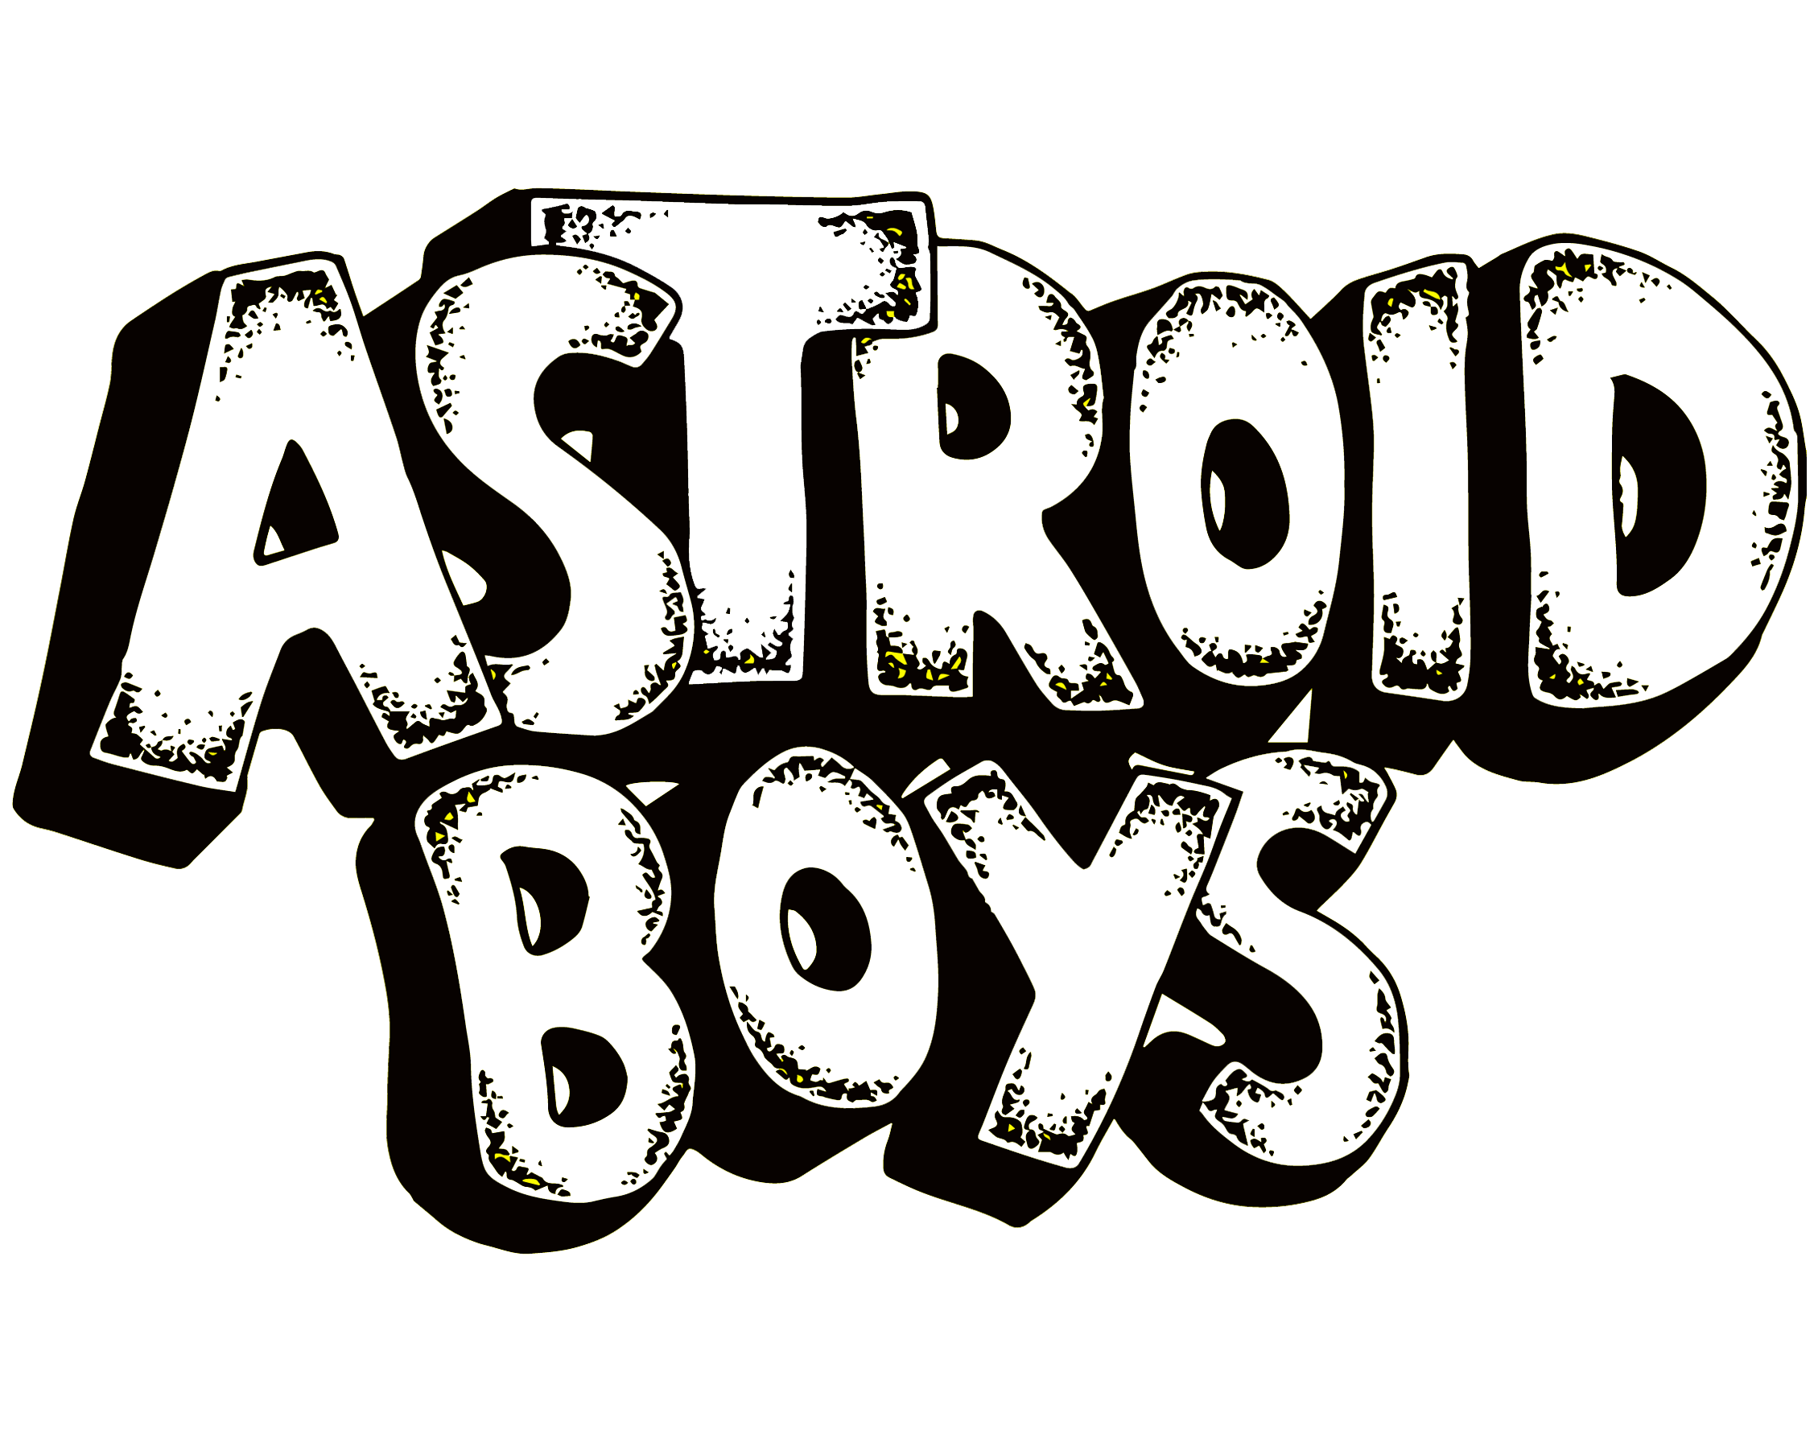

Traxx – Vox
Benji - Vox
Dellux – Producer
DJ Comfort – DJ
Big H - Drums

Erupting out of Cardiff, Astroid Boys’ dangerous blend of Grime, Metal, Hip-Hop and Hardcore has been turning heads since the release of their debut, self-produced and self-released EP, “Bacon Dream” in July 2013.

Chance meetings of like-minded acquaintances through the local skateboard culture gave birth to a unique and authentic sound combining the unlikely quintet’s love for everything heavy and hip-hop, whilst ticking boxes in all corners of EDM and nods towards hardcore punk in between. First and foremost, Astroid Boys are a lifestyle band that exhales it’s culturally aware and grassroots embodiment with every breath.

“What’s really good about being broke? We don’t have to rap about being rich”

Word of the band began spreading quickly with their unique style leaving questions in audiences mouths as to what it was they were actually listening to. Was it hardcore? Was it grime? The release of the original and quirky video for single “Minging” in April 2013 answered many of those questions for the converted. Astroid Boys are simply… Astroid Boys. A personality of their own that they perspire through every orifice.

The launch of the EP, Bacon Dream found the band landing tours with bands and artists ranging from Lethal Bizzle to Trash Talk and King 810 to Professor Green. It’s on a live stage where Astroid Boys show their true colours. Heavy electronic sub-bass and crunching metal guitars turn the most passive of crowds into a prison rioting nail bomb. Unpredictability and well humoured front men matador diverse crowds through their hoops, making the band one of the countries most unmissable live-acts. Whether it be on large stages performing at, Download Festival, Glastonbury, T In The Park, Boomtown and Nass or tiny basements rubbing shoulders with hardcore bands, Astroid Boys sound connects boundlessly. Selling out their debut headline tour back in Feb 2014 only goes to show how far this band have come in their short existence.

The group haven’t been able to avoid their fair share of trouble, which is what happens when growing up on the wrong side of tracks in South Wales. Unfortunately in Nov 2013 – Co-Frontman, Benji was sentenced to a 1 year stay at Her Majesty’s pleasure for an involvement in a fight that lead to injury. Most sadly, this occurred whilst the charismatic vocalist was in fact defending himself. Benji was released in Nov 2014 and the crew are now firing on all cylinders for their 2nd EP Release. “CF10” will be released on April 13th 2015.

For more information on Astroid Boys contact Matt Bradbury @ Pivotal Management.
E – matt.bradbury@pivotalmgmt.com
T – +44 (0) 7803 434845

Visit the band at:
www.facebook.com/astroidboys
www.twitter.com/astroidboys
www.youtube.com/shortfusephil

